Fiber Bragg grating strain sensing at 50 kHz
Bart Johnson
16 May 2018

Abstract
Transient strain measurements using a fiber Bragg grating sensor were made at a sampling rate of 50 kHz using a swept laser tunable between 1252 and 1360 nm. The strained Bragg grating wavelength was referenced to an unstrained grating to subtract out a common mode 19 pm RMS wavelength jitter in the swept laser. Speed could be traded for sensitivity by averaging multiple measurements. The sensitivity was 3.4 µε/√N, where N is the number of averages. This corresponds to 0.02 µε/√Hz.

Introduction
Optical coherence tomography has been the driving force behind the development of rapidly swept lasers [1]. These sources are also suited for Bragg grating interrogation. The laser used in this study sweeps 1252-1360 nm in the short to long direction every 20 µs (50 kHz) with a 50 pm linewidth. These “short cavity” lasers have smooth wavelength sweeps and very low noise [2,3,4]. Similar lasers are available in up to 140 nm tuning ranges and 200 kHz sweep rates in the 1310 and 1050 nm wavelength bands.

Static experiments
A Bragg grating was affixed to a 1/4” thick aluminum beam using generic five-minute epoxy. Figure 1 shows the plate, the sensor, and illustrates how a mechanical impulse was applied in dynamic experiments below. A four-point bend test showed the data in Figure 2. The horizonal axis is the calculated strain [5] on the grating and the vertical axis is 10⁶Δλ/λ. The grating response for fused silica fibers should be, according to [6,7], Δλ/λ = 0.78ε. The theoretical line is drawn in on the plot in blue. The fact that our measurements are higher than theory we attribute to the added thickness of the recoated grating and poor fixturing. Whatever the exact calibration, the Bragg grating senses strain and was used in the dynamic measurements described below.

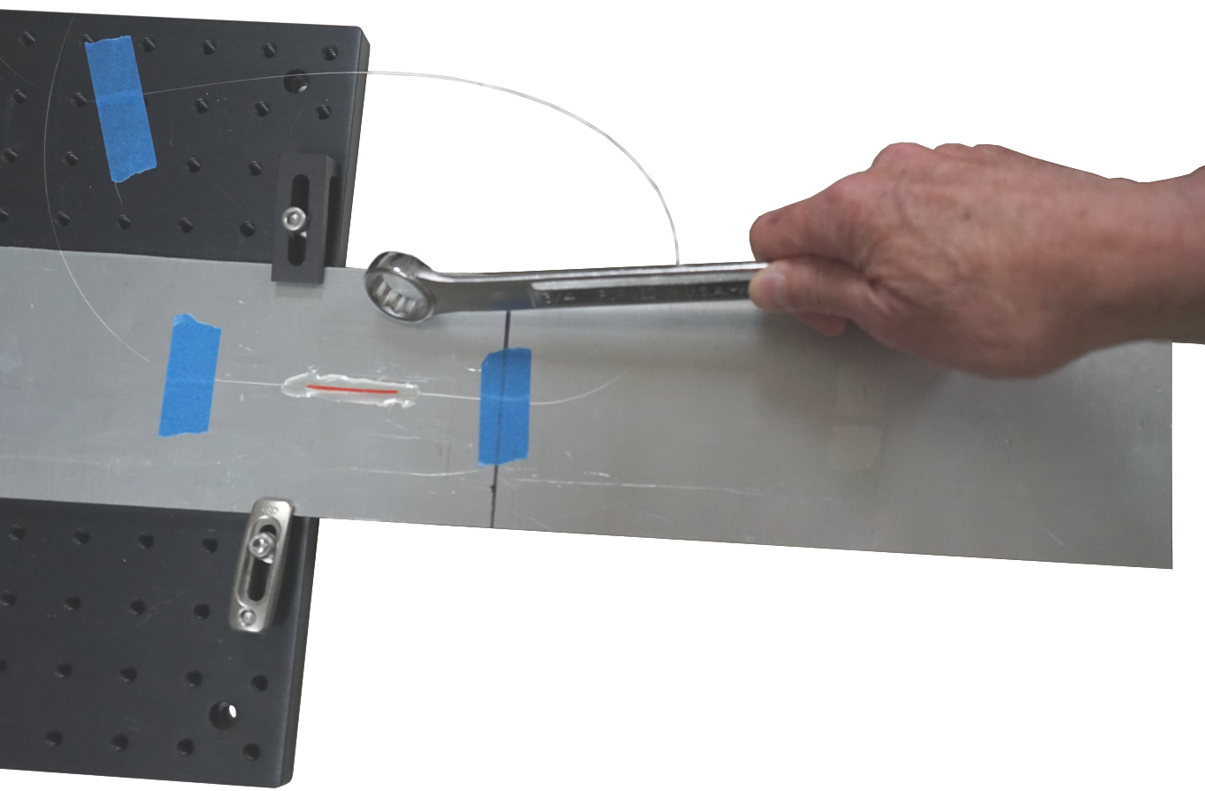
Figure 1. Fiber Bragg grating strain sensor affixed to a ¼” thick aluminum plate and illustration of how a high-frequency strain impulse response was elicited from the setup.

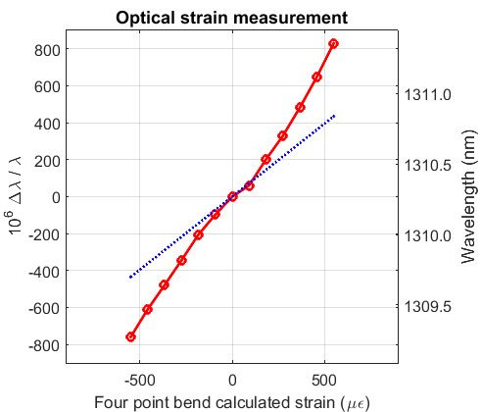
Figure 2. Results of a four-point bend experiment for a Bragg grating strain sensor affixed to a 1/4” thick aluminum plate. The blue line is the theoretical response [6,7] for a fused silica fiber. The slight nonlinearity is due to error in finding the exact zero displacement in the four-point bend setup.
High speed strain measurements were made using the setup of Figure 3. The time-averaged reflectivity spectrum on an optical spectrum analyzer are shown in Figure 4. The longer wavelength grating is used as a strain sensor and the shorter one as an unstrained reference.
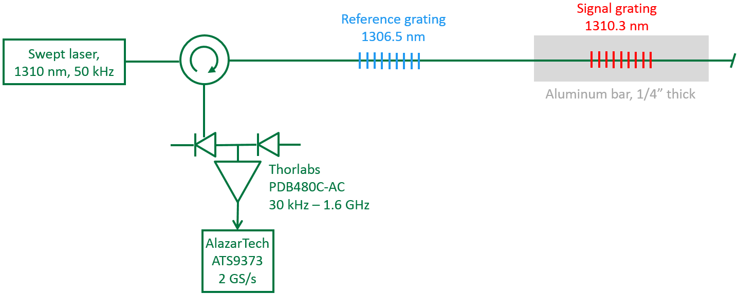
Figure 3. The optical and electrical setup for the dynamic measurements. The high sweep speed and wide tuning range necessitates high-speed detection and digitization of the narrow grating peaks.

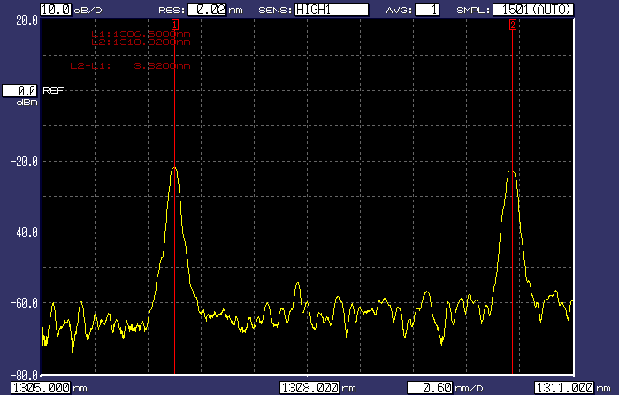
Figure 4. Time averaged reflectivity spectrum from an optical spectrum analyzer (replacing the optical receiver in Figure 3) of the two Bragg gratings. The signal grating is at 1310.3 nm and the reference at 1306.5 nm.
Dynamic experiments
Very high digitization rates are required given the laser sweep rate of 11 pm/ns. The grating peak widths are about 9 ns, corresponding to 18 samples at 2 GS/s. The 100 digitized blue traces in Figure 5 show that there is a sweep-to-sweep wavelength jitter of 33 pm RMS. Fortunately, this jitter is common to the two gratings, so the jitter can be measured using the unstrained reference grating and subtracted off.
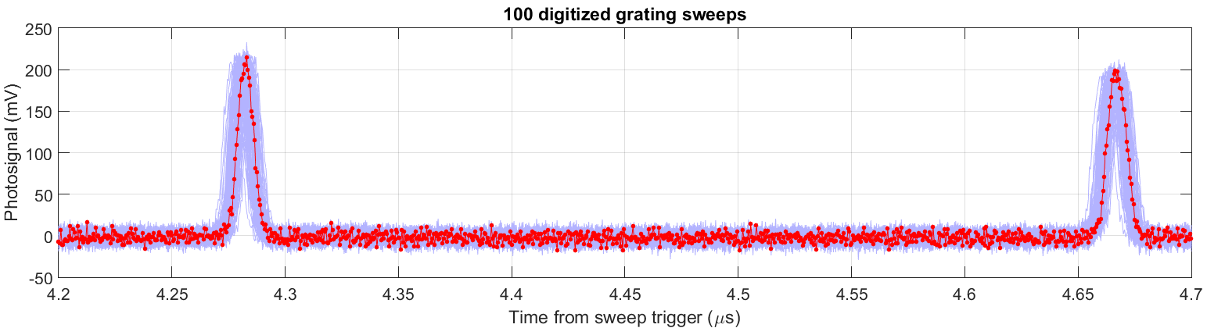
Figure 5. 100 digitized grating sweeps plotted in blue compared to a single sweep in red. This plot shows that there is a 33 pm RMS sweep-to-sweep laser jitter.

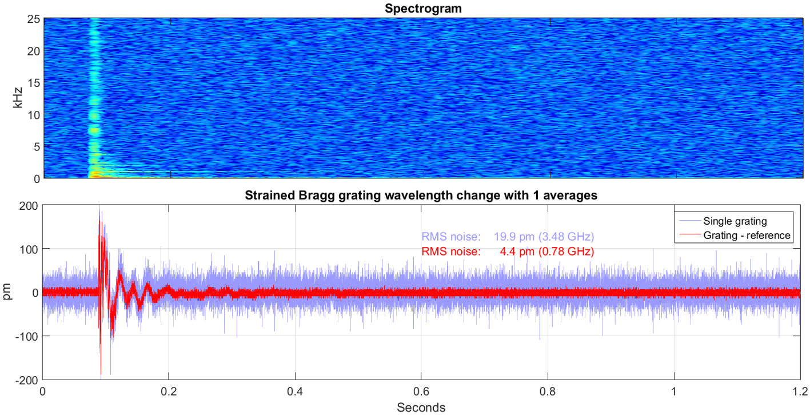
Figure 6. Dynamic strain signal and its spectrogram excited by hitting the ¼” aluminum plate with a box wrench. No averaging was used in processing the data. The two traces show the effect of subtracting off the laser wavelength jitter. The “Grating-Reference” noise floor was 3.4 µε RMS.
The ¼” plate was hit with a box wrench to excite high frequency strains from metal on metal contact as illustrated in Figure 1. The response, shown in Figure 6, shows frequency content into the 10’s of kHz. This is with no averaging. The same data, plotted with 20 averages in Figure 7, erases signals greater than 2.5 kHz, but reduces the noise floor by a factor of 4.5 (√20).

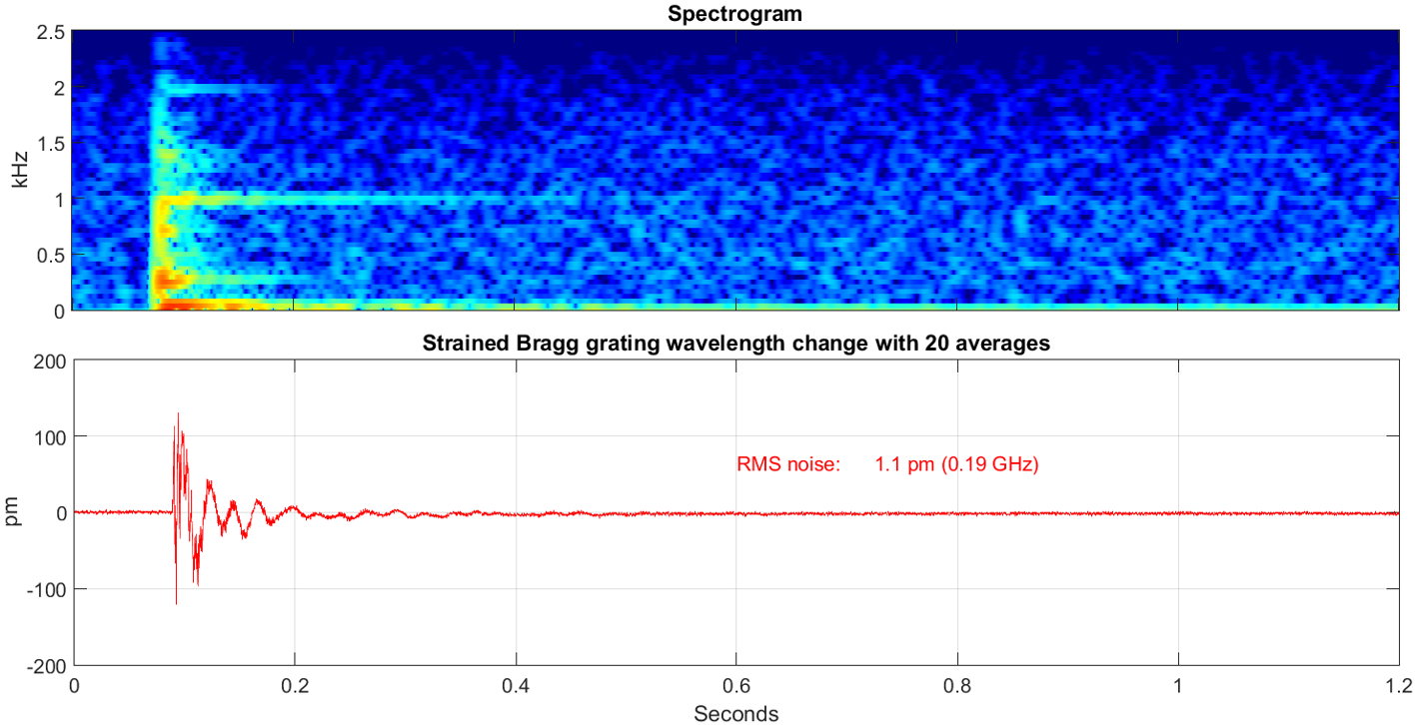
Figure 7. The data from Figure 6 is replotted here with 20 averages. Some of the high frequency content is lost, but the noise floor is a factor of 4.5 (√20) lower. The noise floor is 0.84 µε RMS in this figure.

Audio 1. Clicking the above icon plays the waveform plotted in Figure 7 eight times.

Averaging and sensitivity
There are numerous ways to average data through low pass filtering. Here we discuss averaging N adjacent samples. This is equivalent to a sinc-like function filter in the frequency domain: H(f) = sin(Nπf/f_{s}) / [ N sin(πf/f_{s}) ], where f_{s} is the sampling rate [8]. Figure 8 shows how the bandwidth and noise scale with number of averages. The high sampling rate of the swept laser provides this flexibility. The data points in Figure 8 (right) show that the system departs from the square-root law for more than 1000 averages.

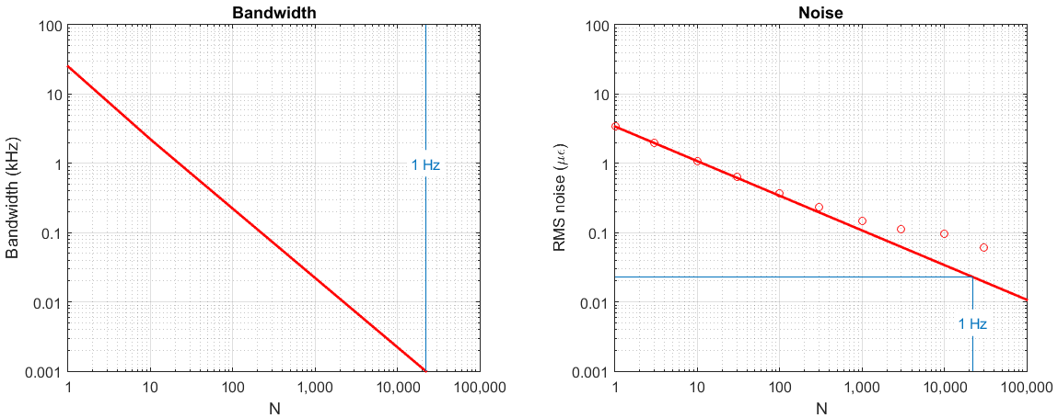
Figure 8. Scaling laws for the 50 kHz system described. A bandwidth of 1 Hz is achieved for 22,000 averaged samples, and the corresponding noise is 0.02 µε for a sensitivity of 0.02 µε/√Hz. There is little advantage to averaging more than 1000 samples since the data departs from the square-root law in the right-hand plot.

Conclusions
We have demonstrated 50 kHz demodulation of fiber Bragg grating strain sensors. The swept laser that made this possible tuned over 100 nm in the 1310 nm band, making multiplexing of many sensors possible. Variations of this laser design can tune 140 nm at 100 kHz. The high sweep speed makes it possible to trade vibration bandwidth for strain resolution. This system has a noise floor of 3.4 µε/√N, where N is the number of averaged measurements. This corresponds to a sensitivity of 0.02 µε/√Hz, which compares favorably to 0.042 µε/√Hz [9] and 0.15 µε/√Hz. [10] in previous work.
References
[1] Optical Coherence Tomography, W. Drexler, J.G. Fujimoto (eds.), Springer International Publishing Switzerland 2015.
[2] B. Johnson, W. Atia, M. Kuznetsov, C. Cook, B. Goldberg, B. Wells, N. Larson, E. McKenzie, C. Melendez, E. Mallon, S. Woo, R. Murdza, P. Whitney, and D. Flanders, “Swept Light Sources”, Chapter 21, 639-658, in Optical Coherence Tomography, W. Drexler, J.G. Fujimoto (eds.), Springer International Publishing Switzerland 2015.
[3] B. Johnson, W. Atia, M. Kuznetsov, B.D. Goldberg, P. Whitney, and D.C. Flanders, "Coherence properties of short cavity swept lasers," Biomedical Optics Express 8, 1045-1055 (2017)
[4] B. Johnson, W. Atia, D.C. Flanders, M. Kuznetsov, B.D. Goldberg, N. Kemp, and P. Whitney, "SNR of swept SLEDs and swept lasers for OCT," Optics Express 24, 11174-11186 (2016)
[5] http://www.structx.com/Beam_Formulas_009.html
[6] C.D. Butter and G.B. Hocker, “Fiber Optics Strain Gauge”, Applied Optics, 17, 2867-2869 (1978)
[7] S. Magne, S. Rougeault, M. Vilela, and P. Ferdinand, “State-of-strain evaluation with fiber Bragg grating rosettes: application to discrimination between strain and temperature effects in fiber sensors”, Applied Optics, 36, 9437-9447 (1997)
[8] The Scientist and Engineer’s Guide to Digital Signal Processing, Steven W. Smith, Second Edition, Chapter 15 “Moving Average Filters”, California Technical Publishing (1999) http://www.analog.com/en/education/education-library/scientist_engineers_guide.html
[9] S.H. Yun, D. J. Richardson, and B.Y. Kim, “Interrogation of fiber grating sensor arrays with a wavelength-swept fiber laser”, Optics Letters 23, 843-845 (1998)
[10] G. Gagliardi, M. Salza, P. Ferraro, P. De Natale, “Fiber Bragg-grating strain sensor interrogation using laser radio-frequency modulation”, Optics Express, 13, 2377-2384 (2005)

